Name : Saurabh Sanjay Jadhav

Topic : Terraform setup and EC2 resource creation.

Assignment no. :

1. Open VS code application. In it open the Terraform folder.

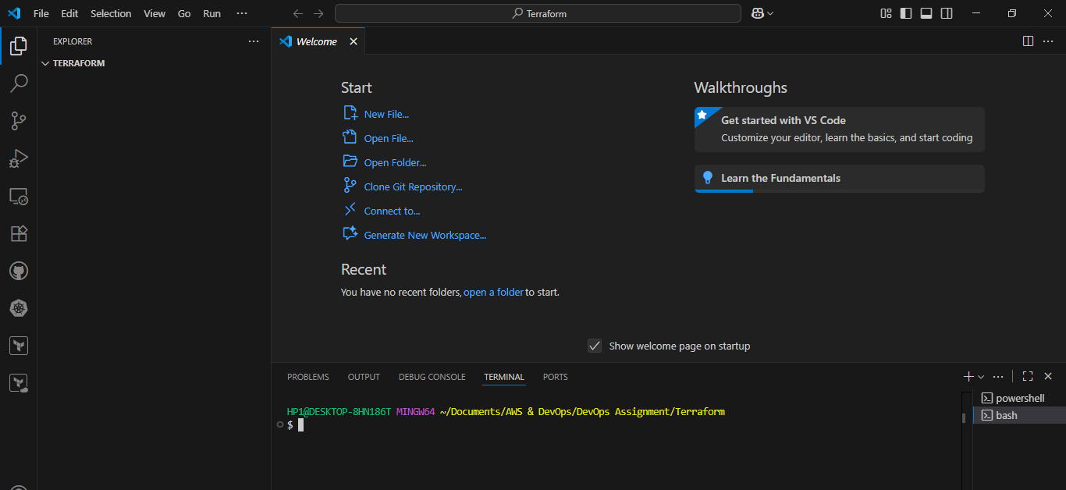

1. Setup AWS CLI using “aws configure” and provide access key, secret key, region and output format.

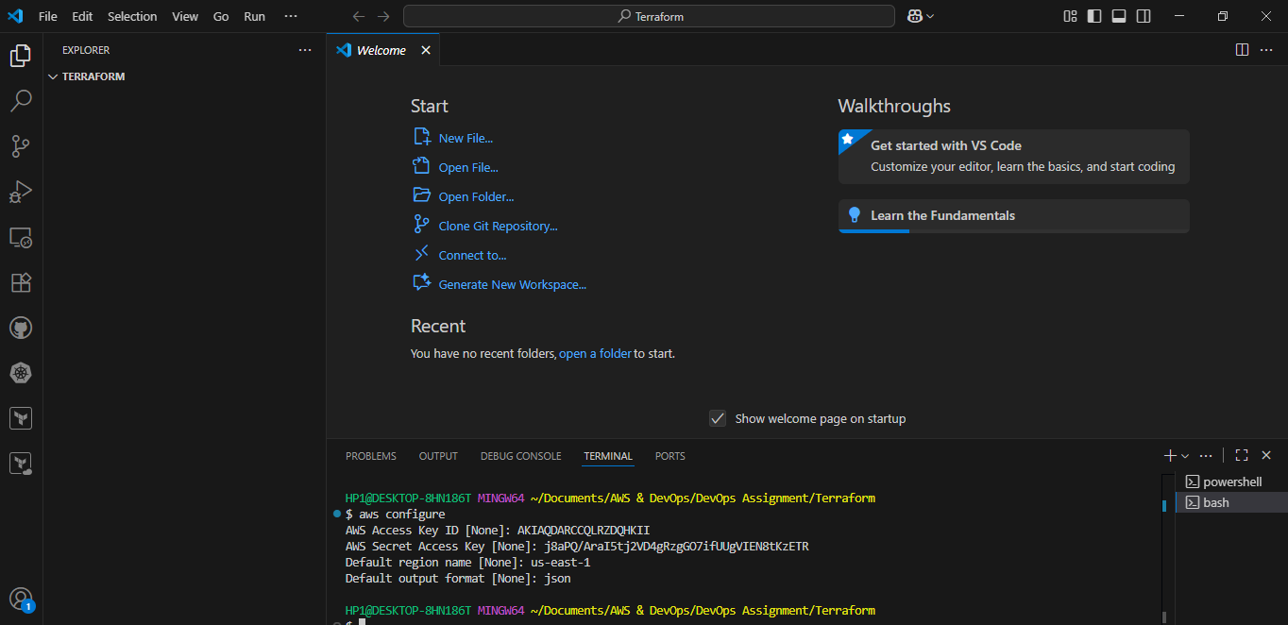

1. Create 4 files
2. Provider.tf
3. Main.tf
4. Variable.tf
5. Output.tf

Add the aws details to provider.tf file

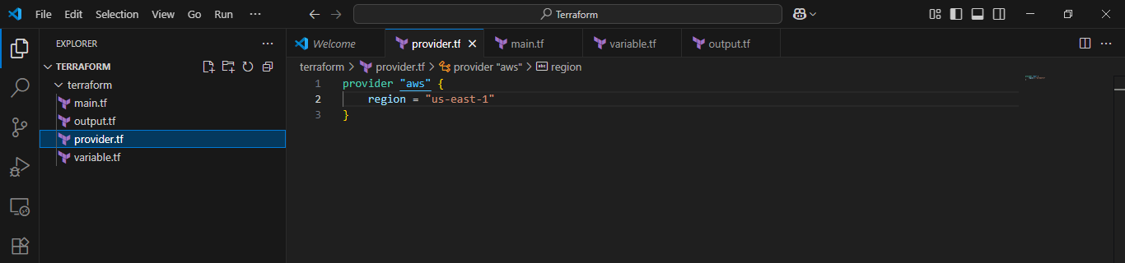

Provide resource details in main.tf file

Resource “aws_instance” “server-1” {

Ami = “ami-0de716d6197524dd9”

Instance_type = “us-east-1”

Tag = {

Name = “sample-instance”

}

}

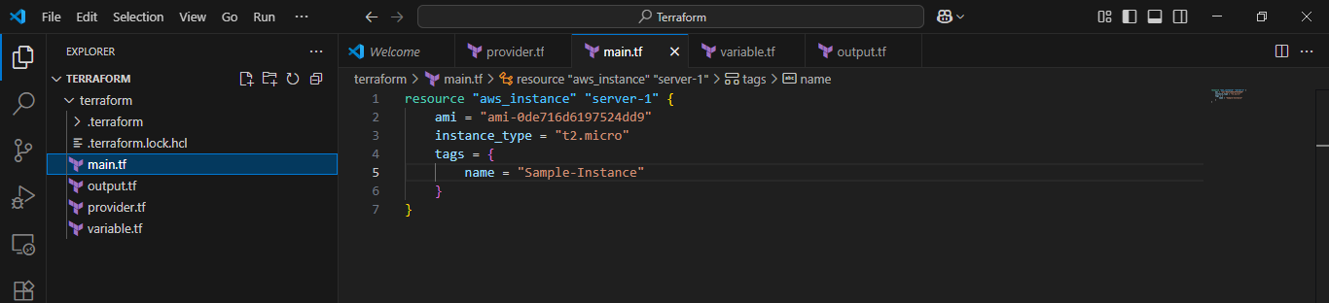

1. Initialise terraform in the folder. It will create terraform.lock.hcl file.

It contains terraform version details.

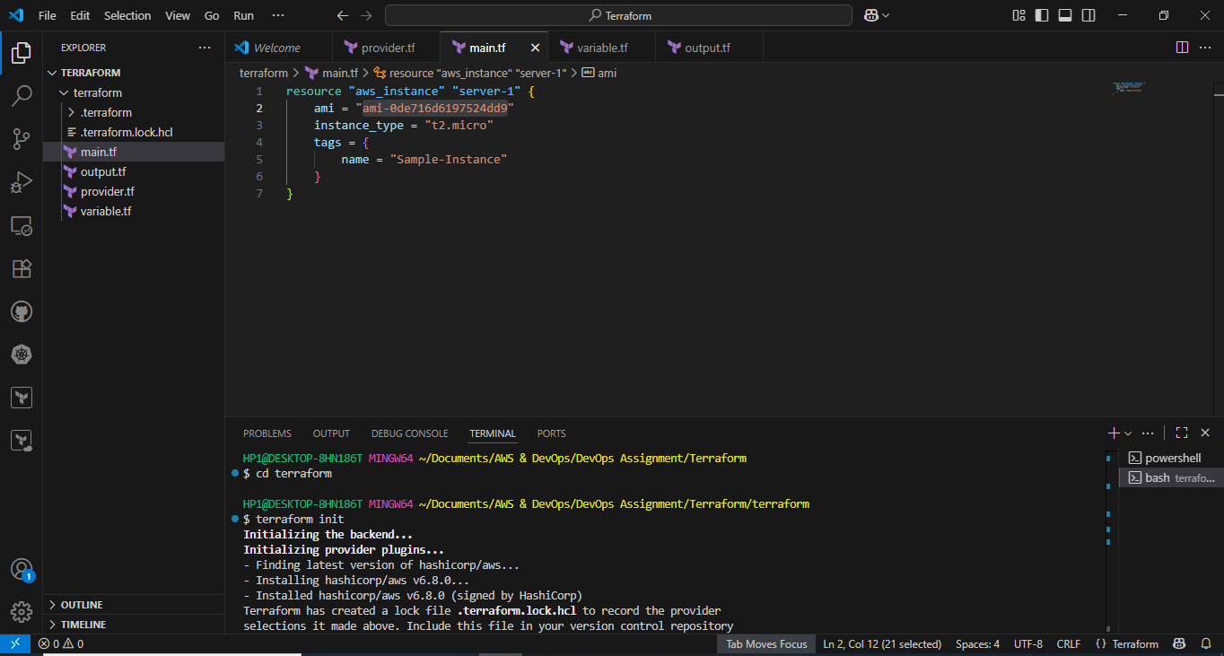

1. Terraform plan command

It will provide detailed information about the resources we are going to provision.

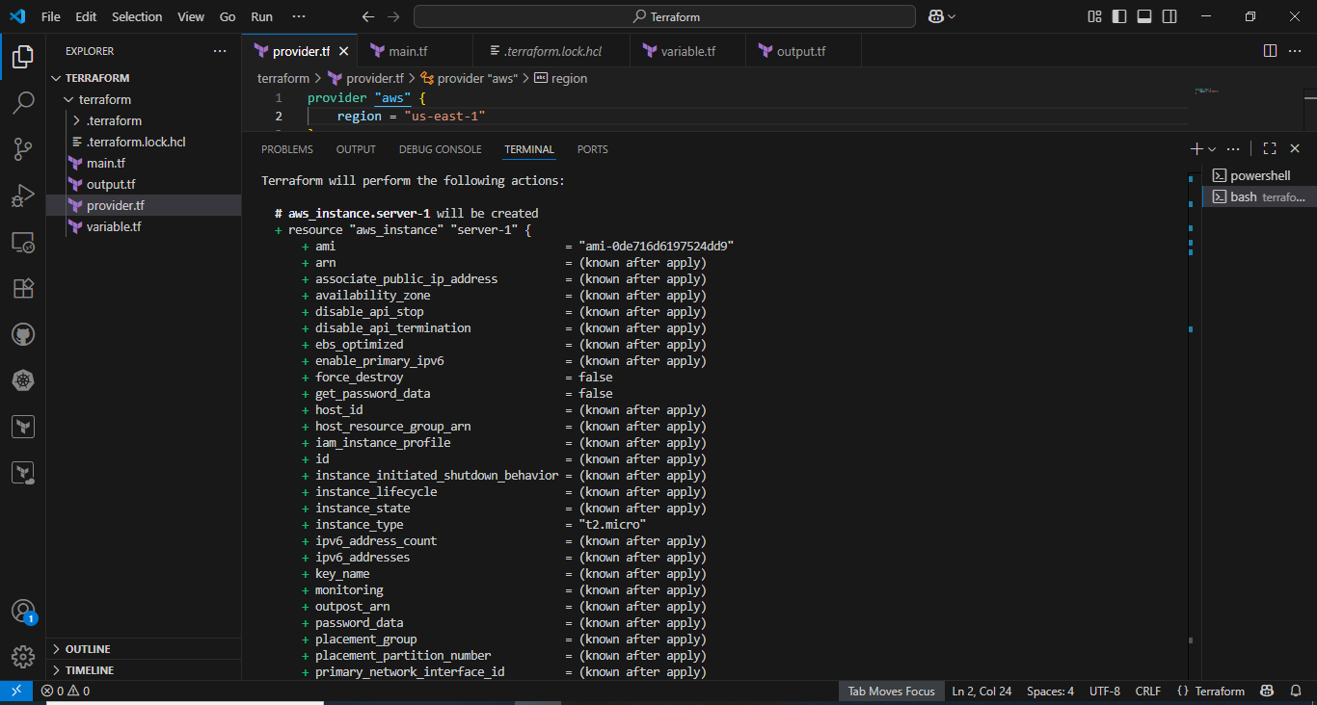

1. Terraform apply command

It will create EC2 resource in aws console. It will also create a state file for instance.

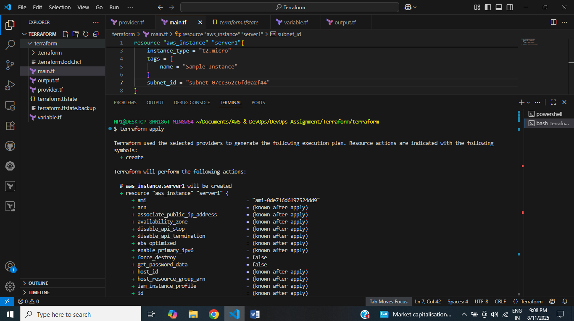

Successfully created EC2 instance.

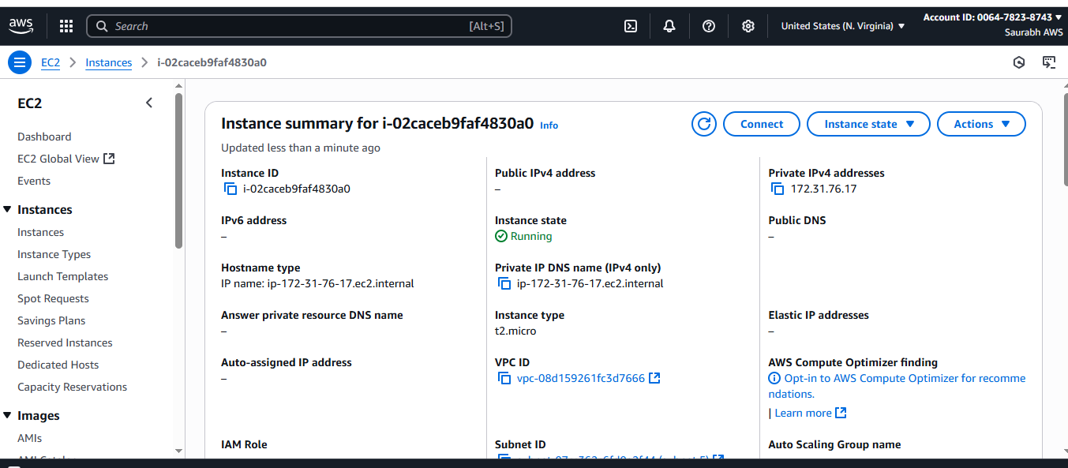

1. Terraform Destroy –auto-approve command.

It will terminate the EC2 instance.

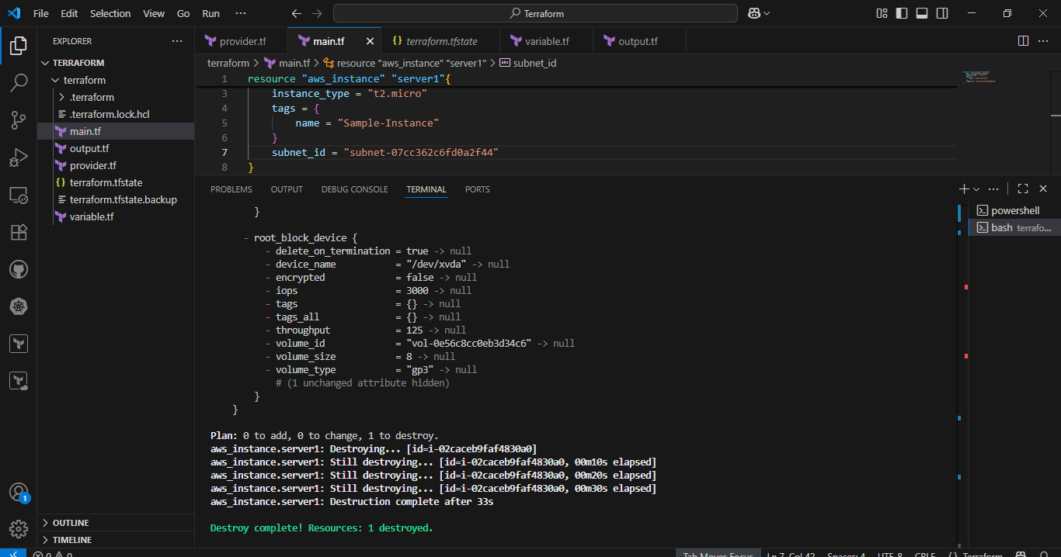

EC2 instance successfully terminated.

